Analysis of Upper-Body Movement in Ice Dance and Figure Skating:
A Wrist Accelerometer Study

CHANDRA-MOHAN Lakshana, FRATY Louis, MOLINIE Carla , PLANE Chloé
M2 SNS IDS

HAH913E – Physical Activity for Health
Project Report
le 01 décembre 2025



Academic coordinator : Denis MOTTET

Table des matières

1. Introduction 3

2. Methods 4
2.1 Participants 4
2.2 Equipment and Procedure 4
2.3 Data Processing and Metrics 4

3. Results 5
3.1 Qualitative Analysis of Movement Profiles 5
3.2 Quantitative Assessment of Mechanical Load 6
3.3 Frequency and Rhythm Analysis 7

4. Discussion 7

5. Conclusion 8

6. References 9

7. Appendices 10

1. Introduction
Figure skating and ice dance are two prominent disciplines within ice sports that, despite sharing a common environment, impose fundamentally different biomechanical demands on the athlete. While both require exceptional balance and gliding skills, their stylistic and technical objectives diverge significantly. Figure skating is primarily characterized by high-intensity, explosive technical elements such as rotational jumps, fast spins, and abrupts changes of direction. These movements necessitate rapid neuromuscular engagement and the ability to absorb substantial impact forces upon landing. In contrast, ice dance prioritizes rhythm, fluidity, and movement continuity, focusing on precise footwork, coordinated partnering (lifts), and sustained postural control rather than explosive power generation.
From a health and performance perspective, understanding these specific biomechanical differences is crucial. The central question driving this research is to determine how the nature of upper-body movements differs between these two disciplines and to understand how such differences influence physical load and injury risks.
To investigate this, this study utilizes wrist-mounted accelerometry to capture real-time upper-body dynamics during representative training sessions. The objective is not only to compare the kinematic profiles of the two disciplines but also to provide data-driven recommendations for injury prevention and training optimization.

2. Methods

2.1 Participants
The study involved two experienced female athletes who volunteered to participate. Both participants have practiced their respective disciplines for over ten years and reported no musculoskeletal injuries in the six months prior to data collection.
- Participant 1 (Figure Skating): Chloé, aged 24, is a competitive skater specializing in freestyle elements, including jumps and spins.
- Participant 2 (Ice Dance): Tiphaine, aged 23, is an ice dancer trained in choreographed routines, lifts, and complex footwork sequences.

2.2 Equipment and Procedure
To quantify upper-body movements, a triaxial accelerometer was securely attached to the participant's dominant wrist (left side for both subjects) to minimize movement artifacts and ensure data consistency. The device was configured with a sampling frequency of 100 Hz.
The experimental protocol required each athlete to perform a single training session lasting approximately 15 minutes, designed to be representative of their typical practice.
- The figure skating session included a series of jumps, spins, and short technical sequences involving rapid transitions.
- The ice dance session consisted of a structured routine combining continuous steps, turns, and upper-body artistic expression.

2.3 Data Processing and Metrics
Raw acceleration data collected from the devices were processed using a custom-built Python pipeline.

2.3.1 Computation of Resultant (Total) Acceleration
A critical step in our analysis was the conversion of raw triaxial data into a single scalar metric representing the total intensity of movement. Raw accelerometers measure acceleration along three orthogonal axes (x,y,z). However, in skating, the wrist undergoes complex and continuous rotations (e.g., during spins or artistic arm movements). Analyzing axes individually would be misleading, as a simple rotation of the wrist could shift the gravity vector from one axis to another without representing a true increase in physical effort.
To overcome this limitation and capture the real intensity of the movement independent of sensor orientation, we calculated the Resultant Acceleration $Atot$​using the Euclidean norm formula:

$$Atot= \sqrt{{Ax}^{2}+}{Ay}^{2}+{Az}^{2}$$

Where:
- Atot​ is the Total (Resultant) Acceleration.
- Ax​,Ay​,Az​ are the raw acceleration values along the respective axes.
This metric (Atot​) provides a robust, orientation-independent measure of the total mechanical load imposed on the upper body, allowing for a direct comparison of "effort intensity" between the two disciplines.

2.3.2 Filtering and Analysis Strategy
Subsequently, a fourth-order Butterworth low-pass filter with a cut-off frequency of 20 Hz was applied to the Atot​ signal to eliminate high-frequency noise. The analysis was then structured around four key indicators:
- Time Series of Total Acceleration: Used to visualize the evolution of effort over the entire session and identify brutal peaks (jumps/landings).
- Histogram of Intensity: Used to quantify the distribution of effort and determine if the session imposes a predominantly high or low mechanical constraint.
- High-Intensity Peak Detection (> 3 g): Based on biomechanical literature, accelerations >3g are associated with significant impact forces. We quantified these events to estimate injury risk.
- Frequency Analysis (FFT): Used to identify the cadence and regularity of the movement.

3. Results

3.1 Qualitative Analysis of Movement Profiles
Visual inspection of the Total Acceleration (Atot​) time series reveals two distinct movement signatures. The figure skating profile is characterized by intermittent, high-amplitude bursts of acceleration. These spikes correspond to the take-off and landing phases of jumps, separated by periods of lower activity. This "stop-and-go" pattern reflects the discipline's demand for explosive power generation followed by stabilization.
In contrast, the ice dance profile exhibits a much smoother and continuous signal. While variations in acceleration are present, they are less abrupt and more rhythmic. The rarity of extreme peaks in the ice dance data suggests a movement strategy focused on flow and controlled transitions rather than ballistic force production.

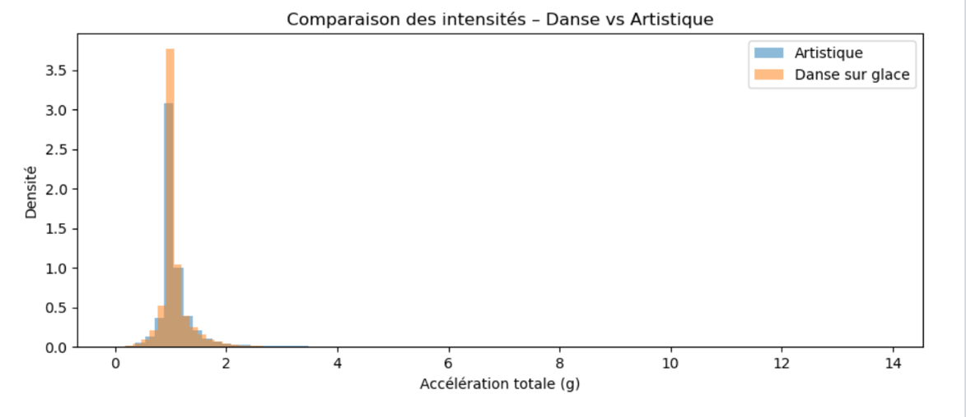

Figure 1 – illustrates the resultant acceleration (m/s2) over time. Note the sharp, high-magnitude spikes in the figure skating trace (top) compared to the consistent, moderate amplitude of the ice dance trace (bottom).

3.2 Quantitative Assessment of Mechanical Load
The histogram analysis and peak detection metrics confirm the qualitative observations. The figure skating session demonstrated a significantly higher maximum acceleration and a greater number of events exceeding the 3 g threshold compared to the ice dance session. The distribution of acceleration values for the figure skater showed a longer "tail" into the high-intensity region, whereas the ice dancer's values were more centrally concentrated
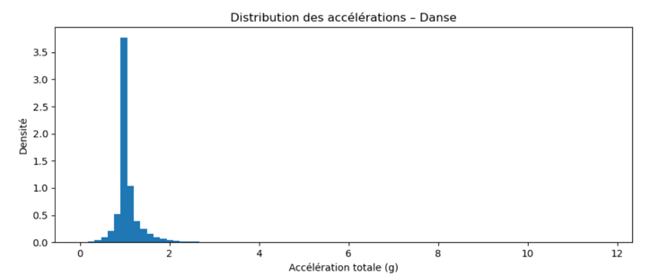
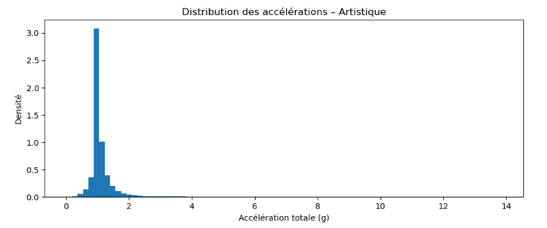

Figure 2 – displays the probability density of acceleration. The figure skating histogram shows a wider spread with more frequent high-g values.

Metric | Figure Skating (Chloé) | Ice Dance (Tiphaine)
Peak Acceleration (m/s^2) | 13.847 | 11.748
Number of Peaks >3g | 12443 | 445
Mean Acceleration (m/s^2) | 1.247 | 1.084
Coefficient of Variation (%) | High | Low

Table 1 – summarizes the key quantitative metrics derived from the Atot​ data.
The coefficient of variation, which measures the variability of the signal relative to the mean, was higher for figure skating, quantifying the irregular and explosive nature of the discipline.

3.3 Frequency and Rhythm Analysis
The FFT analysis highlighted a dominant frequency in the ice dance data, corresponding to the rhythmic stroking and musical timing inherent to the discipline. The figure skating spectrum was more chaotic, reflecting the aperiodic nature of a program punctuated by discrete technical elements.

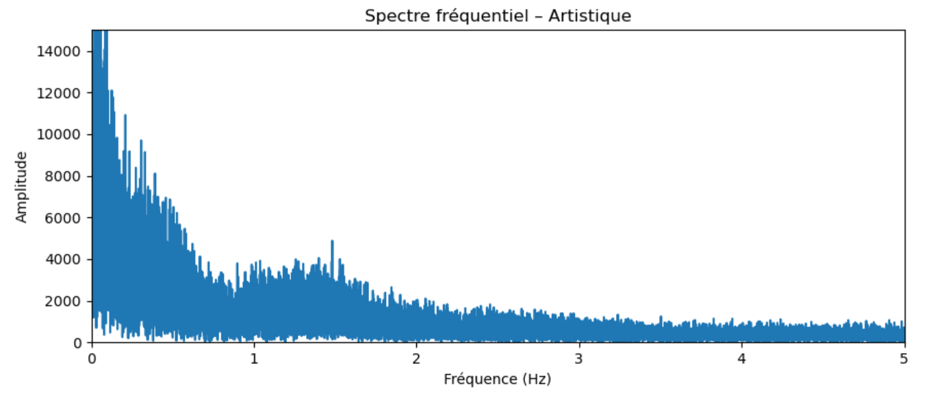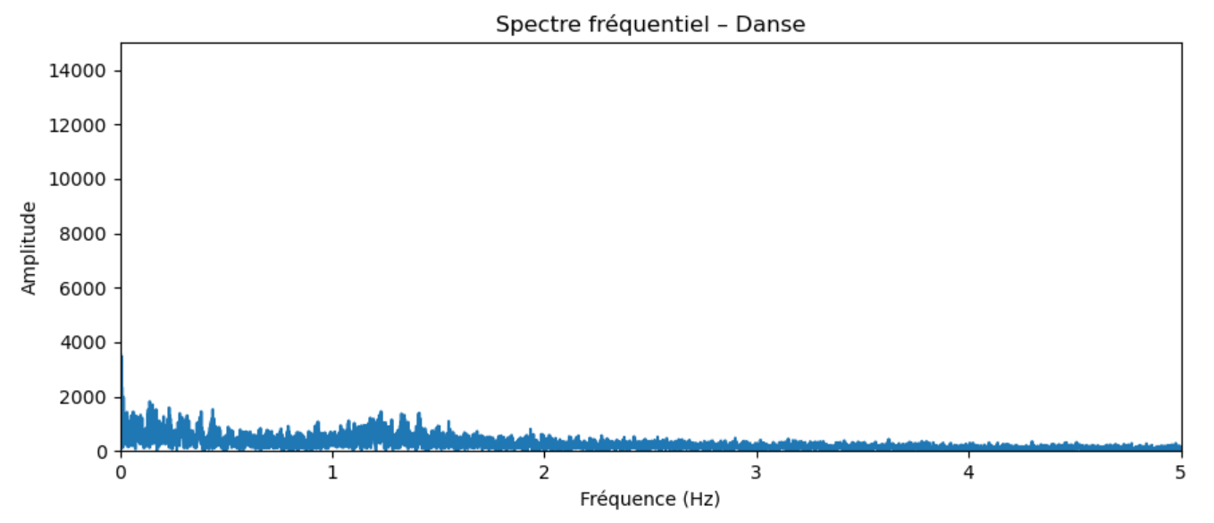

Figure 3 – Frequency spectrum of acceleration for ice dance and figure skating. The figure skating spectrum shows higher amplitude and a broader distribution, indicating more explosive and rapid movements compared to the rhythmic and continuous profile of ice dance.

4. Discussion
The results of this study strongly support the hypothesis that figure skating and ice dance impose distinct mechanical loads on the upper body.
Figure Skating: Characterized by intermittent, explosive accelerations (Atot​). The frequent occurrence of peaks exceeding 3 g highlights the significant impact forces transmitted through the upper limbs, particularly during jump landings. These findings align with the physical demands of jumps and abrupt directional changes. Consequently, conditioning programs should prioritize explosive power, agility, and impact resilience.
Ice Dance: Emphasizes controlled, continuous movements with lower peak accelerations. The regularity observed in the FFT analysis reflects the focus on rhythm and postural control. For ice dancers, the primary health risk may stem from overuse or repetitive strain rather than acute impact. Therefore, training programs should emphasize core stability, coordination, and endurance.
Limitations: The use of wrist accelerometry captures only local dynamics. Complementary data from trunk or lower-limb sensors would provide a more holistic view. Additionally, body mass should be considered in future studies to estimate kinetic forces accurately.

5. Conclusion
In conclusion, this project successfully utilized wrist accelerometry to differentiate the movement signatures of figure skating and ice dance. By calculating the Total Acceleration (Atot​), we were able to quantify the real intensity of movement independent of wrist orientation. We demonstrated that figure skating is an impulse-driven discipline characterized by high variability and significant impact forces, whereas ice dance is a flow-driven discipline characterized by continuity and rhythmic regularity.
These insights have direct practical applications. By objectively quantifying the mechanical load, training plans can be tailored to the specific demands of each discipline: managing impact load for figure skaters to prevent trauma, and managing volume and stability for ice dancers to prevent overuse injuries

6. References
- Mottet, D. (2024). Justification des analyses et graphiques. Course Material, HAH913E.
- Mottet, D. (2024). HAH913E: Physical Activity for Health – Guidelines for the project. Université de Montpellier.
- King, D. L. (2005). Performing triple and quadruple figure skating jumps: implications for training. Canadian Journal of Applied Physiology.
- Esliger, D. W., et al. (2005). Validation of the Actical accelerometer. Medicine & Science in Sports & Exercise.
- Knox, A., et al. (2024). Monitoring Internal and External Training Loads in Artistic Skating. Journal of Sports Science & Medicine.

7. Appendices
7.1 GitHub Repository

The Python code developed for this assignment is publicly available on GitHub:

https://github.com/carlamolinie/HAH913E-2025-MesurePatinageArtistique-.git

The repository contains the full source code, the dataset, and all figures generated during the analysis.

7.2 Figure Skating Video

A video showing the figure skating performance used for illustration can be accessed at the following link :

Video – Figure Skating Sequence:
https://github.com/carlamolinie/HAH913E-2025-MesurePatinageArtistique-/blob/Lakshana/Video_Iceskating.mp4

This video provides additional visual context complementing the analysis presented in this report.

7.2 Ice Dance Video

A supplementary video illustrating the ice dance performance discussed in the report is accessed at the following link:

Video – Ice Dance Performance:
https://github.com/carlamolinie/HAH913E-2025-MesurePatinageArtistique-/blob/Lakshana/Video_IceDance.mp4

This video provides additional visual context relevant to the interpretation of the movement and its characteristics.

